**How to install wsl (windows subsystem for linux)->**

**1.**

**For windows 10-> turn on Hyper -V and windows subsystem for linux**

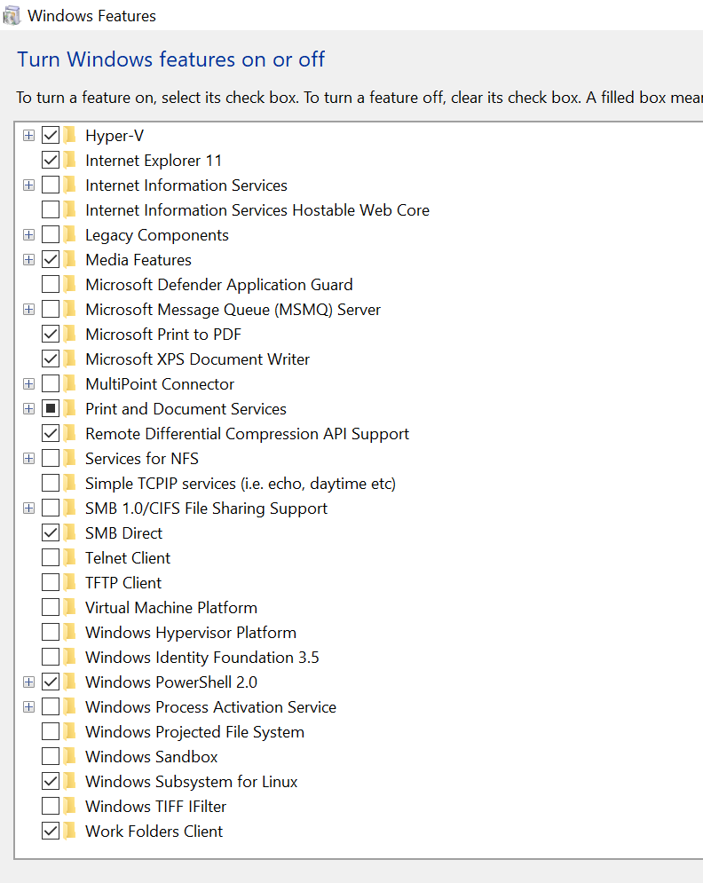

**After that install ubuntu 22.04 LTS form Microsoft store and run it**

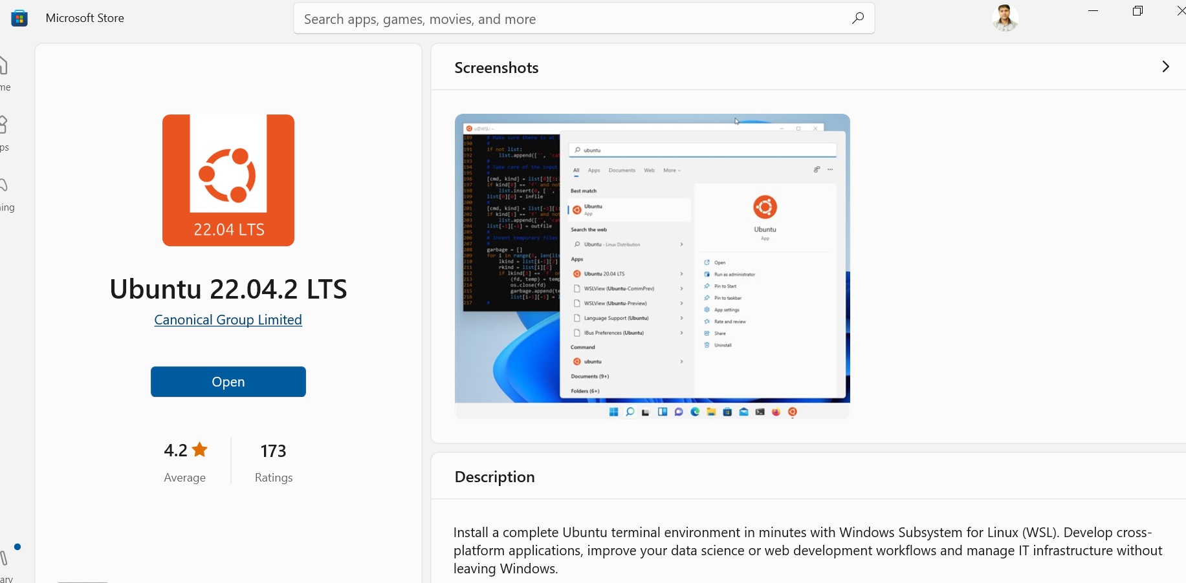

**After that just make username and set password and use linux commands**

**2.**

**For windows 11 -> turn on windows feature virtual machine platform,windows hypervisor platform,And windows subsystem for linux.**

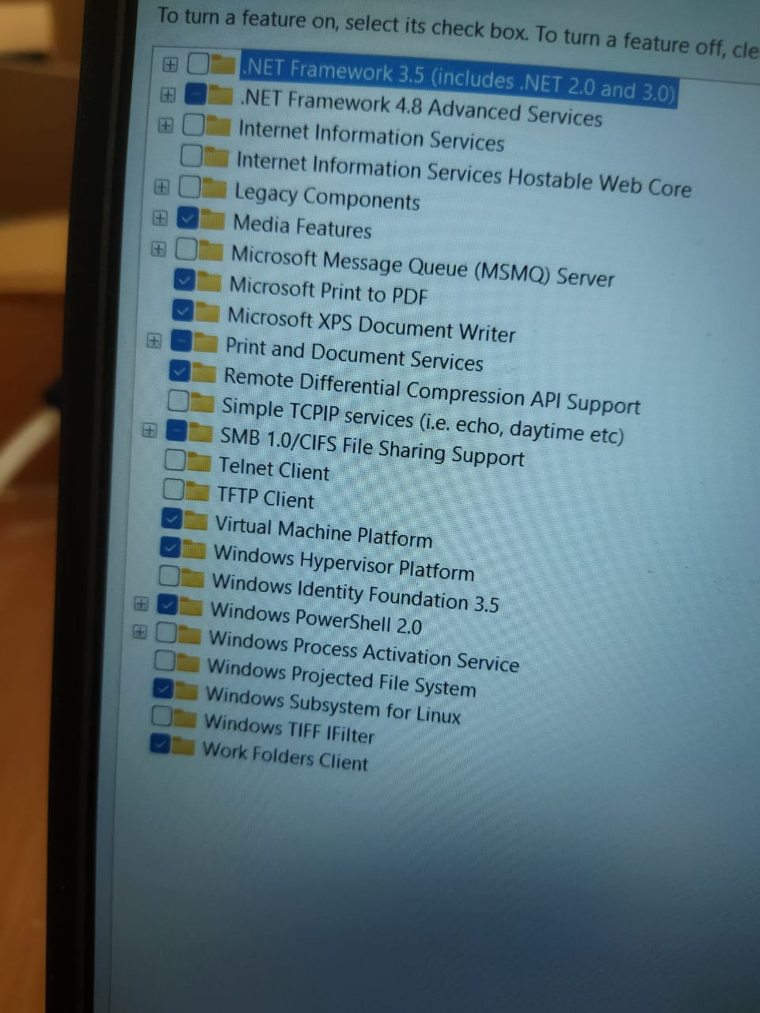

***After that run update command to update wsl using powershell administrator and make sure you connect with internet->***

**wsl --update**

**After that install ubuntu 22.04 LTS form Microsoft store and run it**



**If its not working then go with virtual box installation or dual boot installation**